**DESIGN AND FABRICATION OF A BIO-INSPIRED (Beetle) ROBOT**

**Robotics lab mini project report**

Subject code- ME501

**Submitted by**

Ashish Agrawala-1611MT04

Krishna Agrawal-1611MT07

Shubham Praful Gothale-1611MT13

**2nd Semester**



**DEPARTMENT OF MECHANICAL ENGINEERING**

**Indian Institute of Technology, Patna**

**(April, 2017)**

1.1 INTRODUCTION

In nature, flying insects have remarkable flight performances that constantly capture the human’s attention. The outstanding flight is induced by an external skeleton to which muscles are attached. Muscles connected at the wing root simultaneously create wing flapping and active wing rotation to produce useful aerodynamic forces during upstrokes and down strokes. Thus, insects can use many different flight modes by changing their wing kinematics.

Winged insects exploit several unsteady aerodynamic mechanisms to fly with a low range of Reynolds number. Therefore, understanding the wing kinematics of insect flight is essential for the development of an innovative flapping model that mimics insect flight. Wired flight tests for forward flight were undertaken to verify the effect of wing rotation on force generation, consequently, on the forward flight velocity. Finally, we conducted force measurement to measure the vertical force generated by the flapper.

1.2 DIMENSIONS

Allomyrina dichotoma beetle is an insect of the Coleopteran order. This kind of beetle is relatively large weighing about 6.0 grams to 10 grams. Its wing span is around 130 mm from wing tip to wing tip. The dimensions of a typical male beetle are a wing span of 129 mm, a distance of 17 mm from the wing base to wing base, a length of 48 mm, a width of 24 mm, and a height of 18 mm.

1.3 PRELIMINARY DESIGN

We designed and fabricated a flapping-wing system that can create a large flapping angle just like a beetle. For this purpose, we used a combination of a modified Scotch yoke mechanism and a linkage mechanism. The Scotch yoke mechanism was chosen because it can perfectly transform a rotary motion into a pure sinusoidal motion.

2.1 FABRICATION OF SETUP

For the fabrication of the robot the following components were used:

* 30 × 30 mm acrylic sheet of thickness 5mm - 1
* 50000 rpm Brushless DC Motor – 1
* 3mm and 2mm diameter bolts – 9

2.2 MECHANISM DESIGN

The Scotch yoke mechanism was chosen because it can perfectly transform a rotary motion into a pure sinusoidal motion. Fig. 1 shows the mechanism and full three-dimensional isometric view of the flapping system The Scotch yoke mechanism has two prismatic columns, which are placed side by side in a parallel manner; they act as guiding rails for the slider. The motion of the crank is created by a motor and a pair of gear; the crank was fixed to a large gear and rotated with the same angular velocity as the gear.

The crank has a pin that engages with the slot of the slider; as the result, the rotary motion of the crank is directly transformed into a linear motion of the slider. A coupler was used to connect the slider and the output link: it forms a linkage system that transforms the reciprocating linear motion of the slider into a large flapping motion of the output link.

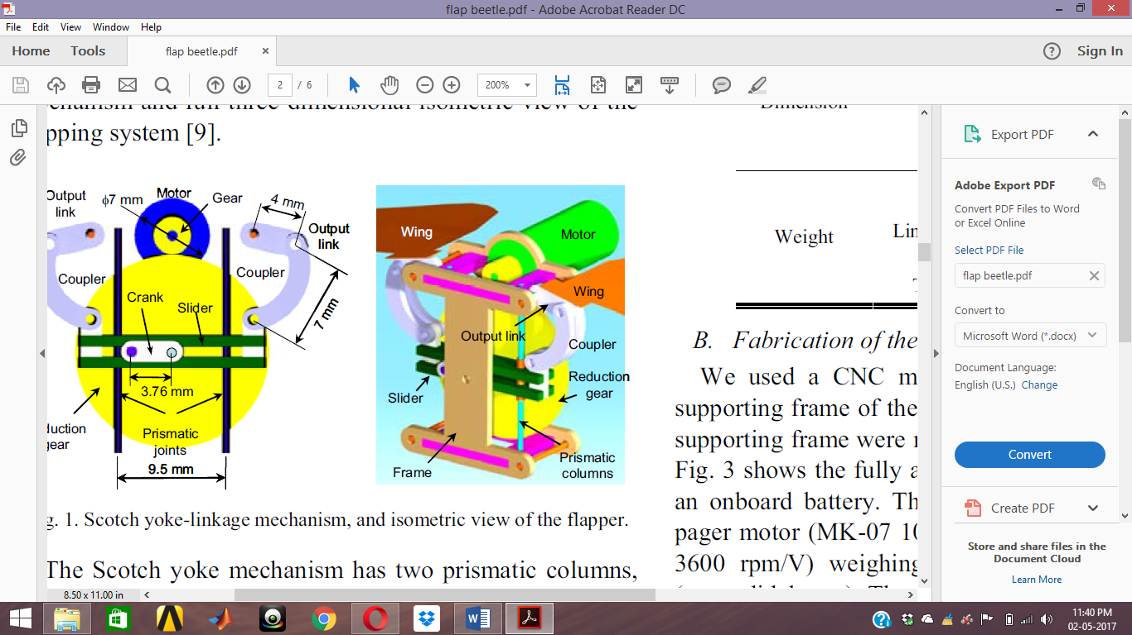

Fig 1: Wing mechanism

2.3 TESTING

Some of the screenshots taken during the testing of the robot are attached below. The figure below shows the moment when the robot was assembled.

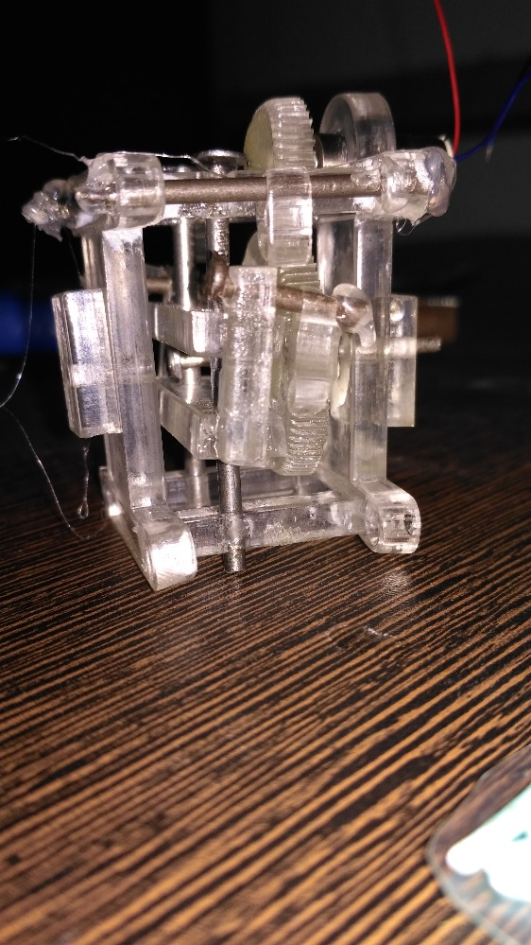

Fig 2

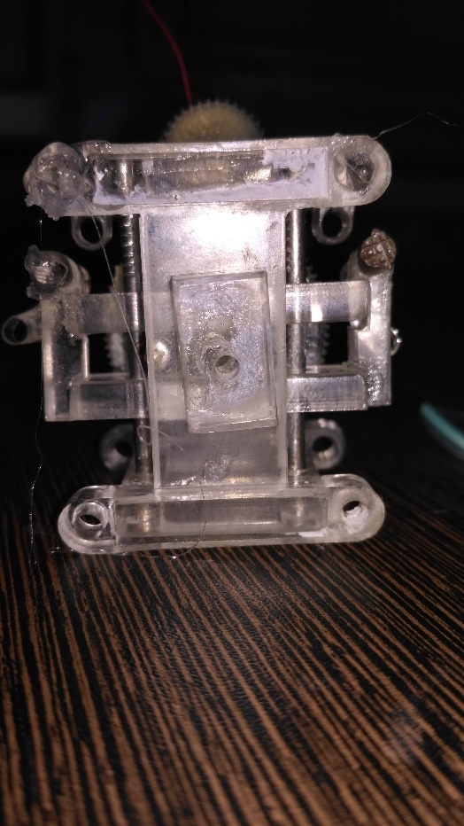 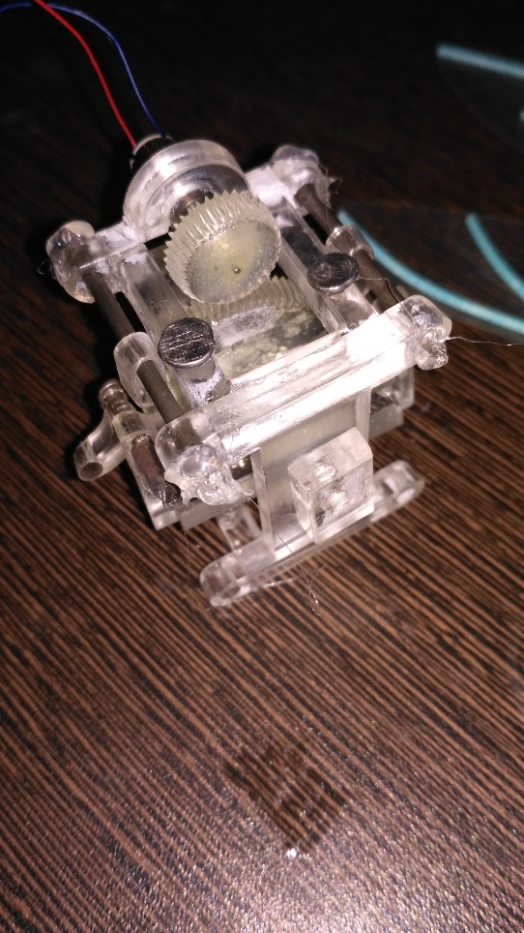

Fig 3 Fig 4